**From:** Caliwliw, Ferdinand   
**Sent:** Friday, January 29, 2016 10:45 AM  
**To:** Thiam Kiat, Goh; Austin, Liew; Chong, Yuit Oon; Low, Dennis; Chong, Ooi Mun; Tan, Yanto; Tan, Derek; Chin, Kin-Wei  
**Cc:** Malinao, Rommel; Low, Dennis; Chua, Chong-Hwang; Lee, Qinyi Kenneth; Lee, Ivan; Kwong, Aaron  
**Subject:** RE: AC KGB Handover Manifest

Hi Goh,

Please refer to below summary of items discussed and sample screen designs of HAWB Scanning and Handover Manifest.  Thanks.

**HAWB Scanning**

1. Ops key-in their Employee No

2. Ops will key-in Carrier or Forwarder

                System will auto-assign a Manifest Number

3. Ops start to scan HAWB

                *** If HAWB has multiple cartons, Ops will need to scan the HAWB for all the cartons

                                else he will not be able to continue to scan another HAWB

                                *** Need your comments on this logic as Ops may intentionally scan the HAWB

                                                on the same carton a number of times for the required number of cartons.

4. Ops to key-in password

                *** Optional Shipwave functionality (need to assess impact with other IT colleague - RHO)

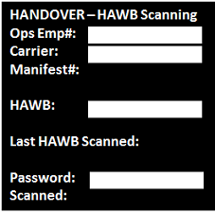

**HANDOVER MANIFEST with signatories from Schenker, Carrier, Security**

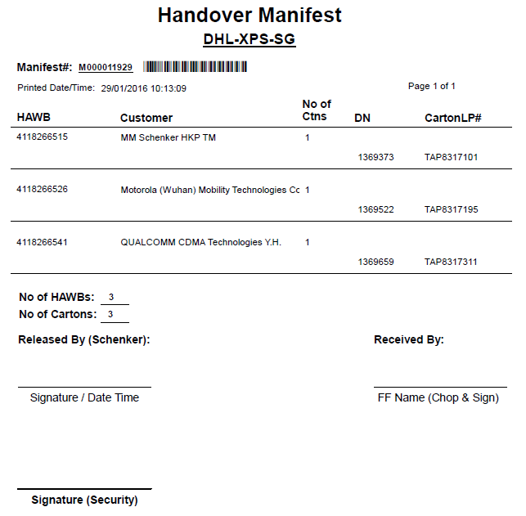

Best regards,

Ferdinand Caliwliw (Mr)  
Senior Systems Analyst  
IT Solutioning Department